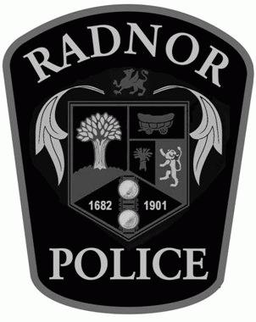

**July 11, 2022 through July 17, 2022**

