January 2, 2024
Dear Customer,
I am writing to you to provide details regarding Aqua Pennsylvania’s upcoming construction work that is scheduled in your neighborhood or place of business. The week of January 15, 2024 Aqua Pennsylvania will begin the replacement of 1300 feet of ductile iron water main on Brooklea Road between Meadowood Rd and Hickory Ln, Fairfax Rd between Hickory Ln and house 137 in Radnor Township.
The $425,000 project is part of our continuing infrastructure improvement program that replaced more than 28 miles of aging main in Delaware County in 2023 to improve service reliability for customers. The new water main will reduce the potential for main breaks, discolored water and improve water flow in the area.
Construction will generally take place weekdays between 7:30 a.m. and 3:00 p.m. During times of construction, access will be provided for emergency, mail and trash service. Residents will have access to their properties, but at times may need to enter from different directions due to changing work zones. Following installation, the new main will be flushed, chlorinated and tested for water quality before being placed into service. During the chlorination/testing phase, activity on the job site will be limited. Once the water quality testing has been completed, we will transfer each water service and fire hydrant to the new main. When all final connections are made to mains on side streets, the old main will abandoned. It is important to note the trench will be covered with temporary blacktop at the end of each workday.
We will notify customers ahead of any planned water service interruptions and will provide 24 hours advance notice for any scheduled interruption greater than 30 minutes. Aqua will have an inspector on the job each day to answer your questions.
Apart from the specific project details described here, you may refer to the accompanying door hanger for more information on what to expect as we begin our construction project in your neighborhood.
In addition to reaching our customer service staff and emergency dispatcher at the number listed on the doorhanger accompanying this letter, you may also call us with any questions regarding the project at 610.328.7713.

Sincerely,
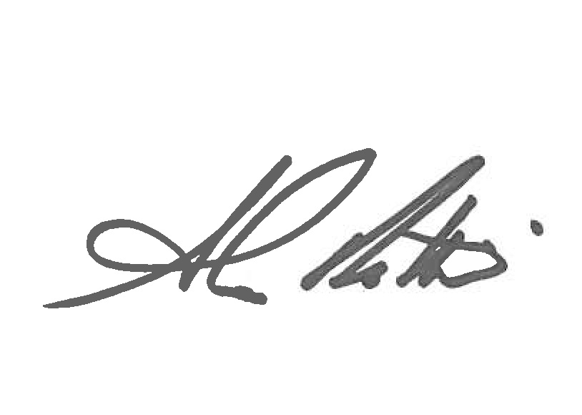
Alan Roth
Manager of Construction

